University of Northern British Columbia

Between Budget and the Planet: Sustainable Economic Solutions in Canadian Healthcare

Jessica Hainstock & Paul Escarez
Economics 204: Contemporary Economic Issues
Professor Muhebullah Karimzada
April 4th, 2025

The healthcare paradigm in Canada is crucial to maintaining individual social welfare and the continuity of the healthcare program. Financial viability in healthcare contains too little discussion. Analyzing the broad subject of healthcare sustainability for the healthcare industry, the individuals, and the environment is an urgent area of research. Examining the challenges such as healthcare expenditures, technological advancements, and the principles behind sustainable healthcare concerns suppressing the possibility of healthcare sustainability. Environmental sustainability as a direct offset of healthcare sustainability is integral to make note of by healthcare sectors in their pursuit of optimal and sustainable service, and backing the claim of being a champion of human health. “Quangos” as an agent of either sustainable success or environmental detriments enables us to make sense of slim areas of concern where healthcare sectors can take action. This research paper will propose alternatives to the current healthcare model for better healthcare sustainability. These proposals will concern expanding preventive & community-based care, Indigenous-led healthcare expansion, resource efficiency, and greener healthcare reforms. Sustainability should begin by ensuring that growth in healthcare spending does not affect access to non-healthcare-related services and the overall quality of an individual’s life. A holistic approach should not just prioritize financial stability among others, but achieve optimal health outcomes for current and future generations.

To start, what is healthcare sustainability? As the United Nations’ 1987 Brundtland Report put it, “development that meets the needs of the present without compromising the ability of future generations to meet their own needs” (Tsasis et al, 2019, p. 531). Rethinking a new healthcare model improves the general population’s underachieving health outcomes. Healthcare can be sustained through active programmes, health benefits, recovery costs, adaptability to change, and a range of valued service opportunities. Tsasis et al. (2018) state, “Canada spends almost $200 billion annually in healthcare” (p. 2). In 2023, healthcare expenditures reached $330 billion (12.2% of GDP) (Canadian Institute for Health Information [CIHI], 2023), placing pressure on public finances. Inability to sustain healthcare capacity for future generations obstructs the healthcare sector’s continuity and the society’s welfare. This financial burden limits government investment in education, infrastructure, and other social services. “Without reforms, rising costs could lead to higher taxes, reduced services, and longer wait times” (Barua et al., 2017). Government spending on healthcare-related services has had an increasing share, with “healthcare spending account[ing] for just over 30% of the provincial government expenditures in 1981/1982, but 45% in 2004/2005.” (Irfan, 2007, p. 51) Addressing such issues can promote healthcare systems that are more equitable and capable of meeting the needs of both present and future generations.

The government spending percentage on non-health-related items, such as education, police services, and social assistance determines the percentage of these government expenses on health-related shares. Funding deficits and cost considerations can block healthcare sectors from sustainability programs. The taxes the government collects automatically are devoted to healthcare ambitions. The current sustainable healthcare model contains few solutions, so rethinking a new model should be prioritized. Rising costs, demographic shifts, and systemic inefficiencies threaten Canada’s sustainability healthcare system. However, strategic policy interventions—such as increased investment in preventive care, greater integration of Indigenous healthcare, and optimized spending—are essential to ensuring its long-term viability. A broader perspective on sustainability highlights the healthcare sector’s need for innovative, efficient, and equitable access to a newly remodelled healthcare approach.
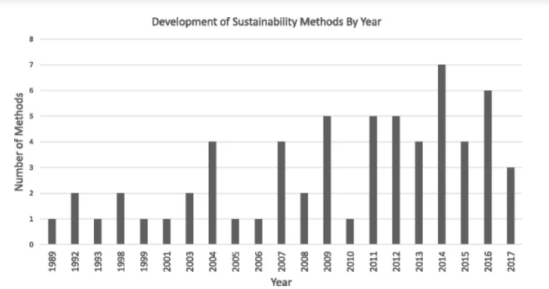
Figure 1

Note. The data shown about the research and development for more sustainable methods in healthcare sectors are from “Navigating the sustainability landscape: a systematic review of sustainability approaches in healthcare,” by Lennox, Laura et al. Implementation Sci. 9 February 2008. https://link.springer.com/article/10.1186/s13012-017-0707-4
Since the workforce is responsible for the sustainability of healthcare, they are also responsible for keeping in check whether sustainable practices are being maintained or neglected. Depending on the environment, rural areas are victims of health access disparities due to smaller pools of healthcare professionals. Healthcare programs are also expensive, obstructing healthcare professionals' distribution. The healthcare workforce will continue to get up-to-date training and equitable pay incentives if supported by ongoing sustainability education. Opportunities for non-physician providers such as community health workers, nurse practitioners and assistants, create fewer worker shortages and an incentive for further workplace efficiency and sustainability. According to Medrano (2024, p. 1), “Expanding training programs and providing financial incentives…alleviate workplace shortages. Scholarships, loan forgiveness programs, and competitive salaries can attract more…to the healthcare field.” Furthering the financial initiative for aspiring healthcare workers can see an eventual boost in numbers in the hospital for sustainability. The introduction of Telehealth can potentially improve the problem of healthcare access, particularly in more rural areas; the uneven healthcare worker-to-patient ratio can be mended through Telehealth. The medical technology field has its advantages and disadvantages. Medical technological advancements tend to increase spending, and integrating new medical equipment, pharmaceuticals, and digital healthcare solutions requires substantial investment. While innovations like telemedicine and AI-driven diagnostics offer cost-saving potential, initial implementation of this technology remains expensive and damaging to the Canadian healthcare budget (Rosenberg-Yunger et al., 2008). Technology in medical environments has both its pros and cons. Compared to developing countries, “there is a technological gap…which often lack access to the latest eco-friendly technologies due to high costs” (Filho et al., 2024, p. 1109). So while technological advancements and financial incentives can address the healthcare workforce’s shortages and enhance healthcare access, its implementation and high costs cannot be understated. By striking a balance between innovation and fiscal responsibility, fostering a sustainable healthcare system and helping all communities becomes even more possible.

With sustainability comes an environmental footprint, concerning the careful use and distribution of hazardous chemicals in medical devices. Ironically, the healthcare sector is resource-intensive and produces excessive greenhouse gas emissions. This is where “sustainable procurement” comes in. According to Schroeder et al., it is defined as “a process whereby organizations meet their needs…in a way that achieves value for money…not only to the organization but also to society and the economy, whilst minimizing damage to the environment” (2012, p. 7). Although ambitious, adopting a more environmentally aware healthcare model provides more sustainable incentives. An institution which intends to safeguard the individual liberty of health should continue to back this claim advocating for and demonstrating sustainable ways of operation. The environmental impact goes hand in hand with healthcare economics as they both concern themselves with the appropriate perspectives to execute sustainability efficiently. According to Lennox et al., assessing the diverse circumstances in healthcare sustainability means “investigating and defining individual constructs” (2008, p. 531). Healthcare sustainability can span from a lack or excess of resource allocation, initiative effectiveness, and the progress of these initiatives over time. Lennox et al. (2008) state that sustainability is grouped into “‘inter-organizational relationships’ that [must] serve as a basis of the collaborative problem-solving capacity.”
(p. 7). Further practice of more mindful catering costs and reducing inpatient and outpatient hospital stays are notable for sustainable healthcare efforts. According to Filho et al., “the transition to renewable energy alone will only address 29% of the overall healthcare sector footprint” (2024, p. 1107). 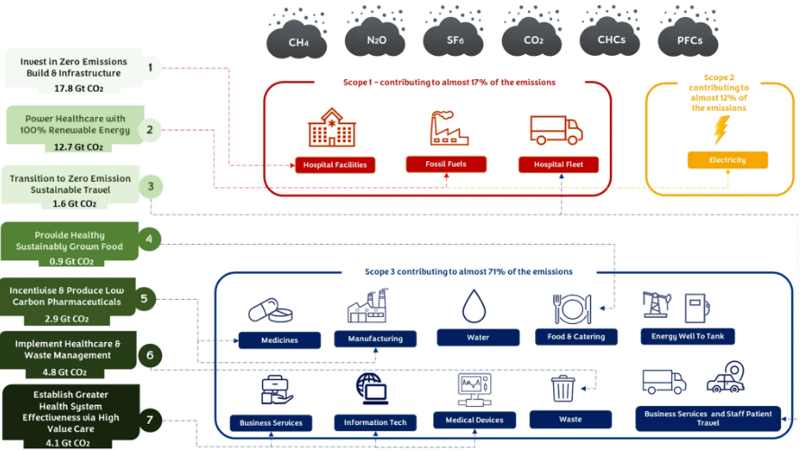As one of the main contributors to greenhouse gas emissions, the healthcare sector tends to contradict its stance in its sustainability efforts. Developing countries of lesser socio-economic standings, and therefore lesser healthcare accesses, see a lack of healthcare sustainability attentiveness by their developed counterparts. The case for sustainable healthcare economics takes an interesting turn through Canadian quangos. “Quangos” stands for “quasi-autonomous non-governmental organization,” which are independent entities with a particular initiative, containing some form of government involvement. Such quangos like the SDTC (Sustainable Development Technology Canada) or CIHI (Canadian Institute for Health Information) have more or less the same end goal; contributing to better understanding and providing solutions for the many areas of healthcare sustainability in Canada. According to Shroeder et al., (2012, p. 2) particular initiatives such as the Canadian Coalition for Green Health Care, or the CCGHC, seek to “encourage the adoption of resource conservation, pollution prevention principles and effective environmental management systems to reduce the Canadian health care system’s ecological impact while protecting human health.” Such initiatives by these quangos are done through extensive empirical research, the provision of healthcare statistics, the implementation of environmental policies, and continued partnerships between like-minded quangos and institutions.
Note. High-impact decarbonization actions to reduce the healthcare sector’s share of GHG emissions; mapped from HealthCare Without Harm’s decarbonization roadmap and based on data from NHS England (2020) and Karliner et al. (2021) Filho Walter Leal et al. “Climate-friendly healthcare: reducing the impacts of the healthcare sector on the world’s climate.” Sustainability Science. vol. 19, 29 March 2024, p. 1103-1109. https://link.springer.com/article/10.1007/s11625-024-01487-5?form=MG0AV3

Figure 2

The operations of quangos can either drive progress or present more detrimental challenges in pursuing sustainable healthcare systems. Healthcare sectors note that the multitude of responsibilities and initiatives that quangos keep in mind, can often overlap and lead to inefficiencies despite aiming for sustainability. Members of healthcare sectors also dismiss the prospect of large-scale optimization and seek smaller healthcare sustainability goals instead. Quangos believe, however, that with this mindset, neglect and underachieving results are usually met. Furthermore, rural areas often gain no attention from initiatives led by quangos, leaving them at a disadvantage and doubting the geographic effectiveness quangos ultimately have. Quangos can be deemed a double-edged sword in healthcare sustainability, and it is evident. They serve as an ambitious blueprint for change and innovation, but their limitations on execution and outreach challenge the healthcare sector in achieving a truly sustainable and equitable healthcare model.
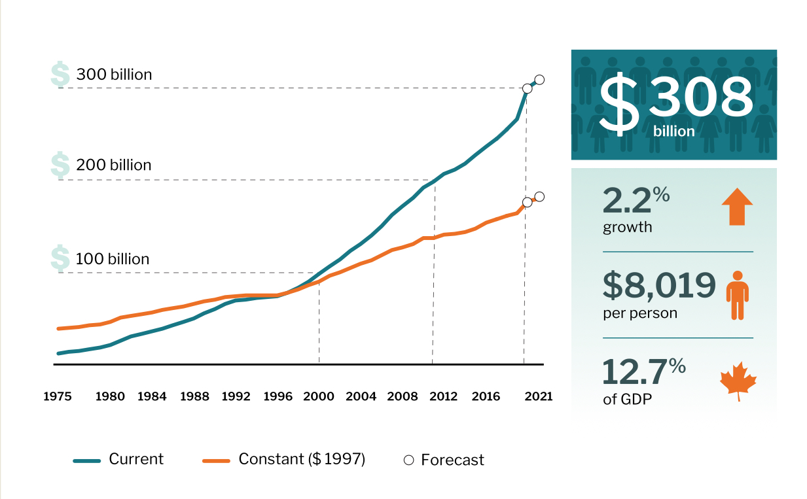
Note. Total health expenditure in Canada climbs to over $308 billion in 2021. National Health Expenditure Database, Canadian Institute of Health Information, 2021. Accessed in March 11th, 2025. https://www.cihi.ca/en/national-health-expenditure-trends-2021-snapshot

Figure 3
The aging demographic in the Canadian population is currently significantly driving healthcare costs because, as Canadians age, they require more extensive healthcare services. By 2030, one in four Canadians will be over 65, which means there will be an increase in long-term care, hospital services, and prescription medications (Government of Canada, 2022). This also means that elderly patients have higher per-capita healthcare costs, making population aging a significant financial challenge (Public Health Agency of Canada, 2021). Also, chronic diseases, such as diabetes, cardiovascular conditions, and mental health disorders, further contribute to rising healthcare expenditures (Rosenberg-Yunger et al., 2008). Canadians with these conditions require ongoing treatment, frequent hospital visits, and expensive medications (Loppie, Wien, & National Collaborating Centre for Indigenous Health, 2022). Indigenous populations in Canada face higher rates of chronic illness due to systemic healthcare inequities and geographic barriers, further increasing healthcare costs (Barua et al., 2017). As a result, the poor management of chronic diseases leads to preventable hospitalizations, straining the system more than necessary (Public Health Agency of Canada, 2021).

If healthcare spending continues rising at its current pace, Canada’s healthcare system may become financially unsustainable within two decades (Di Matteo, 2011). Without proper intervention, these growing costs will likely result in tax increases, reduced healthcare access, and longer wait times (Canadian Institute for Health Information [CIHI], 2023). Creating and implementing strategic policy measures is essential to ensure long-term financial viability while maintaining universal healthcare access (Government of Canada, 2022). The long wait times in the Canadian healthcare system are reducing workforce productivity, increasing patient suffering and creating inefficiencies in healthcare delivery. Fraser Institute (2023) reported that patients in Canada currently wait an average of 27.4 weeks for specialist treatment after receiving a referral–this is significantly longer than the wait time in other high-income countries. Delays in receiving treatment can worsen health conditions, which, as a result, increases healthcare costs–a vicious cycle (Barua et al., 2017). If the government puts effort into improving efficiency through solutions like implementing better triage systems, streamlining referral processes, and utilizing telemedicine, the wait times in the Canadian healthcare system could be reduced. Similarly, increasing the funding for frontline healthcare workers and infrastructure expansion could alleviate healthcare service delivery bottlenecks (Public Health Agency of Canada, 2021).

The first policy recommendation for a sustainable healthcare system is investing in preventative healthcare to reduce the long-term costs associated with chronic diseases by addressing them before extensive treatment is required. Suppose the government were to increase its investment in preventative measures like vaccination programs, public health campaigns, and routine screenings, the increased support in these programs could lead to lower hospitalization rates and, as a result, reduce overall healthcare expenditures (Public Health Agency of Canada, 2021). Additionally, expanding the number and access to community health centers and investing in integrating more nurse practitioners and additional support to physicians would improve accessibility and reduce emergency room congestion–an increasing problem in Canada. 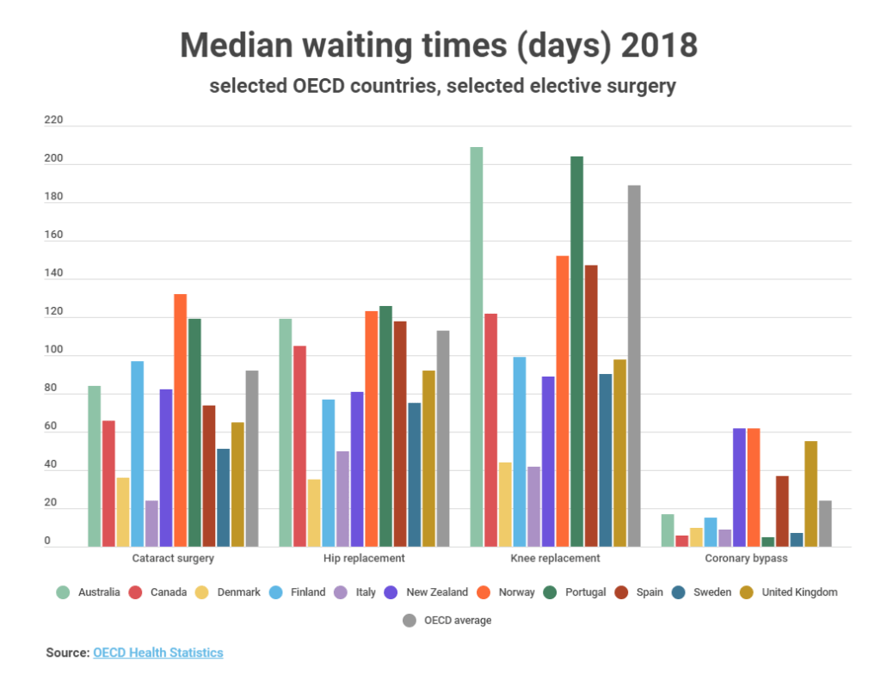
Note. How do waiting times compare internationally? - Q-bital Healthcare Solutions, n.d. Q-bital Healthcare Solutions, 27 April 2021. Accessed in March 11th, 2025. https://www.q-bital.com/how-do-waiting-times-compare-internationally/
Figure 4
Indigenous communities in Canada face unique challenges when accessing healthcare because of geographic barriers and systemic inequities, as a result, they see an increase in chronic disease in their communities. Investing in and supporting Indigenous-led healthcare initiatives, for example, increasing the number of accessible mobile healthcare clinics and culturally competent care programs, could contribute to improving Indigenous peoples' health outcomes and reduce the current strain on urban healthcare systems. Further, by investing funding into Indigenous health practitioners and expanding telehealth services into remote areas–there would be a greater chance of success in long-term sustainability (Loppie et al., 2022).

Equally essential to achieve sustainability, addressing the healthcare workforce shortage is vital. Not just addressing the issue that threatens sustainability and quality of delivery but also working to expand training programs, increasing financial incentives for healthcare professionals to work in rural and remote areas, and improving overall working conditions are steps needed to help retain staff (Medrano, 2024). Similarly, utilizing and leveraging technology like AI-assisted diagnostics and automation in administrative tasks can increase efficiency and reduce labour costs. However, the Canadian healthcare sector significantly contributes to greenhouse gas emissions and waste production. If sustainable procurement policies were implemented to reduce single-use plastics and work towards a transition to renewable energy sources, there could be a reduction in the environmental impact of healthcare facilities (Schroeder et al., 2012). Investing in energy-efficient hospital designs and putting effort towards promoting waste reduction initiatives will increase long-term cost savings while also addressing environmental concerns regarding healthcare.
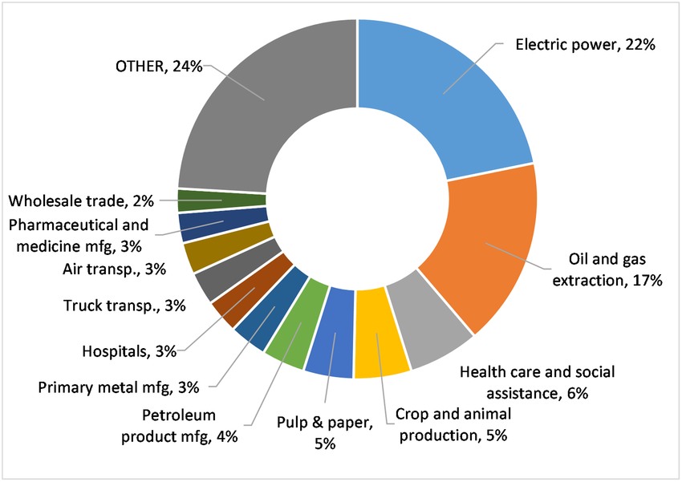
Note. Life cycle environmental emissions and health damages from the Canadian healthcare system: An economic environmental epidemiological analysis. Eckelman et al. 2018. Relative percent contributions of economic sectors to Canadian healthcare life cycle GHG emissions [Figure]. PLOS Medicine. https://www.researchgate.net/figure/Relative-percent-contributions-of-economic-sectors-to-Canadian-healthcare-life-cycle-GHG_fig1_326724932
Figure 5
To conclude, the sustainability of the Canadian healthcare system is at significant risk due to rising costs, aging demographics, and the current inefficiencies within the healthcare system. Without strategic interventions, Canada's current trajectory will lead to increased financial strain, longer wait times, and diminished healthcare quality. To counter this issue, a multi-faceted approach is required to address these challenges–including preventative care, Indigenous-led health initiatives, workforce investment, and reforms. Furthermore, healthcare sustainability is more than an economic issue; it is also a social and environmental issue. Ensuring that healthcare remains accessible and efficient requires an integrated approach that incorporates financial viability, workforce distribution, and consideration of the environmental impact of healthcare operations. Investing in technology, efficiency improvements, and policies that address systemic inequities is key to ensuring long-term resilience in the Canadian healthcare sector. Efficient collaboration between governments, healthcare providers, and communities is essential to achieve sustainability in Canadian healthcare. By prioritizing proactive policy reforms and strategic investments, Canada can work towards building a healthcare system that is financially viable, equitable, and environmentally responsible for generations to come.

References
Barua, B., Palacios, M., & Emes, J. (2017). Healthcare spending more than doubled since 2001; projected to keep growing. Fraser Institute. Retrieved from https://www.fraserinstitute.org/studies/sustainability-of-health-care-spending-in-canada-2017
Canadian Institute for Health Information. (2021). National health expenditure trends, 2021: Snapshot. Retrieved from https://www.cihi.ca/en/national-health-expenditure-trends-2021-snapshot
Canadian Institute for Health Information. (2025). National health expenditure trends. Retrieved from https://www.cihi.ca/en/national-health-expenditure-trends
Dhalla, I. (2007). Canada’s health care system and the sustainability paradox. Canadian Medical Association Journal, 177(1), 51–53. Retrieved from https://www.cmaj.ca/content/177/1/51
Di Matteo, L. (2011). The sustainability of Canadian provincial government health spending: An expenditure category approach. Meetings of the Canadian Economics Association, 1-29. Retrieved from https://www.lakeheadu.ca/sites/default/files/uploads/44/dimatteo/work%20in%20progress/DIMATTEO-CEACDHOWEHealthPaper.pdf
Filho, W. L., Leutz J. M., Thanekar, U. D., Pimenta Dinis, M. A., & Forrester, M. (2024). Climate-friendly healthcare: Reducing the impacts of the healthcare sector on the world’s climate. Sustainability Science, 19, 1103-1109. Retrieved from https://link.springer.com/article/10.1007/s11625-024-01487-5?form=MG0AV3
Government of Canada. (2022). Canada’s aging population: What you need to know. Retrieved from https://www.canada.ca/en/public-health/services/publications/diseases-conditions/aging-population.html
Issa, R., Forbes, C., Baker, C., Morgan, M., Womersley, K., Kalber, B., Mulcahy, E., et al. (2024). Sustainability is critical for future-proofing the NHS. BMJ, e079259. Retrieved from
https://www.bmj.com/content/385/bmj-2024-079259
Lennox, L. L., Maher, L., & Reed, J. (2008). Navigating the sustainability landscape: A systematic review of sustainability approaches in healthcare. Implementation Science, 13(27), 1-17. Retrieved from https://link.springer.com/article/10.1186/s13012-017-0707-4
Loppie, C., & Wien, F. (2009). Health inequalities and social determinants of Aboriginal people's health. National Collaborating Centre for Aboriginal Health. Retrieved from https://www.nccih.ca/docs/social%20determinates/NCCAH-Loppie-Wien_Report.pdf
Medrano, S. (2024). Investing in rural healthcare professionals: Financial incentives and sustainable solutions (Health Canada Policy Brief). Government of Canada. Internal document retrieved from UNBC Library. Public Health Agency of Canada. (2021). How chronic disease is affecting Canadians Retrieved from https://www.canada.ca/en/public-health/services/publications/diseases-conditions/how-chronic-disease-affecting-canadians.html
Q-bital Healthcare Solutions. (n.d.). How do waiting times compare internationally? Retrieved from https://www.q-bital.com/how-do-waiting-times-compare-internationally/
Rosenberg-Yunger, Z., Daar, A. S., Singer, P. A., Martin D. (2008). Healthcare sustainability and the challenges of innovation to biopharmaceuticals in Canada. Health Policy, 87(3), 359-368. Retrieved from https://www.sciencedirect.com/science/article/abs/pii/S0168851008000389
Schroeder, H., FCMC, PMP, CHRP, CHE, and Canadian Coalition for Green Health Care. (2012) “Getting sustainability right in Canadian health care: an art and science approach.” Discussion Paper Series. 1-12. Retrieved from
https://greenhealthcare.ca/wp-content/uploads/2015/12/Getting-sustainability-right-in-Canadian-health-care-an-art-and-science-approach-Coalition-for-Green-Healthcare.pdf?form=MG0AV3
Tsasis, P., Agrawal, N., & Guriel, N. (2019). An embedded systems perspective in conceptualizing Canada’s healthcare sustainability. Sustainability, 11(2), 531. Retrieved from https://www.mdpi.com/2071-1050/11/2/531

